**KDM MID TERM REPORT**

**N.AYYAPPA KUMAR(16157522).**

**INTRODUCTION:**

In order to complete KDM hackathon I chose classifier system. For this system I want to develop an application related Recalls. I want to get all the recalls and classifying them and providing to subscribers as of their request. I used the data from safercar.gov.

The first step is to open the VMWare and save the data into your required folder here I saved the data in to KDM EXAM folder.

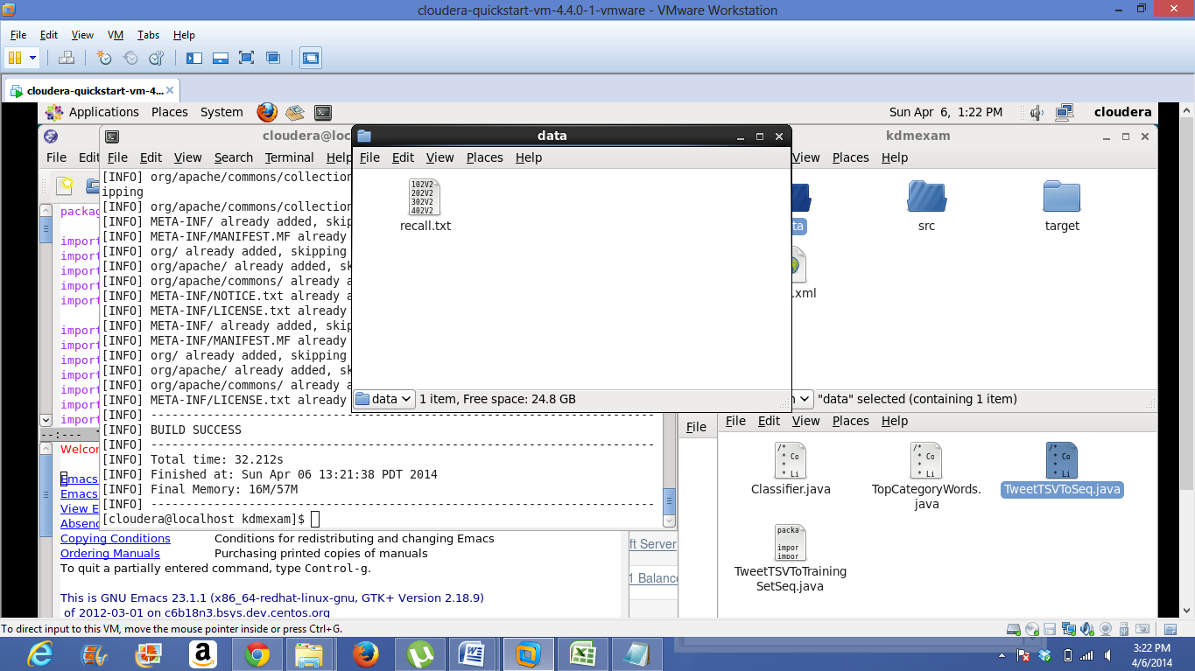

As well as writing the code and placing the code in to src folder. Here I used the code for classifier provided by Dr.Lee in the class and then I further modified the code as of my application requirement.

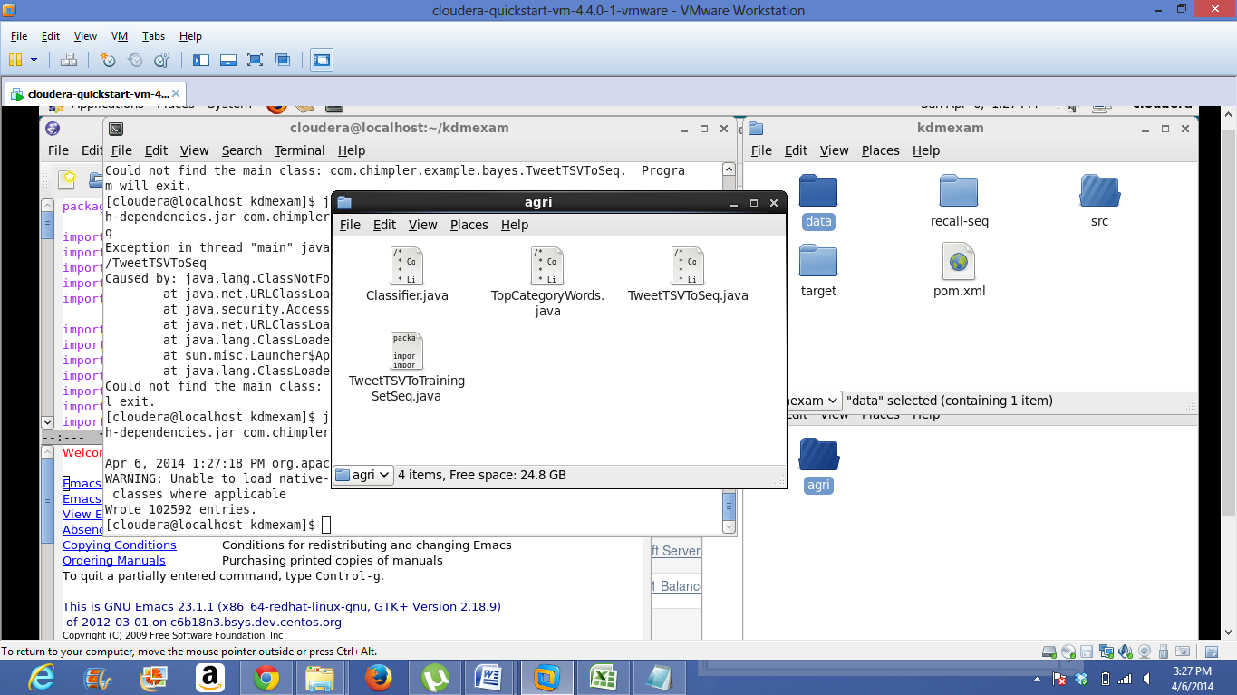

Implement the commands that are specified in tutorial-7

Compilation of the project and generating the target folder

for this use command "mvn clean package assembly:single"

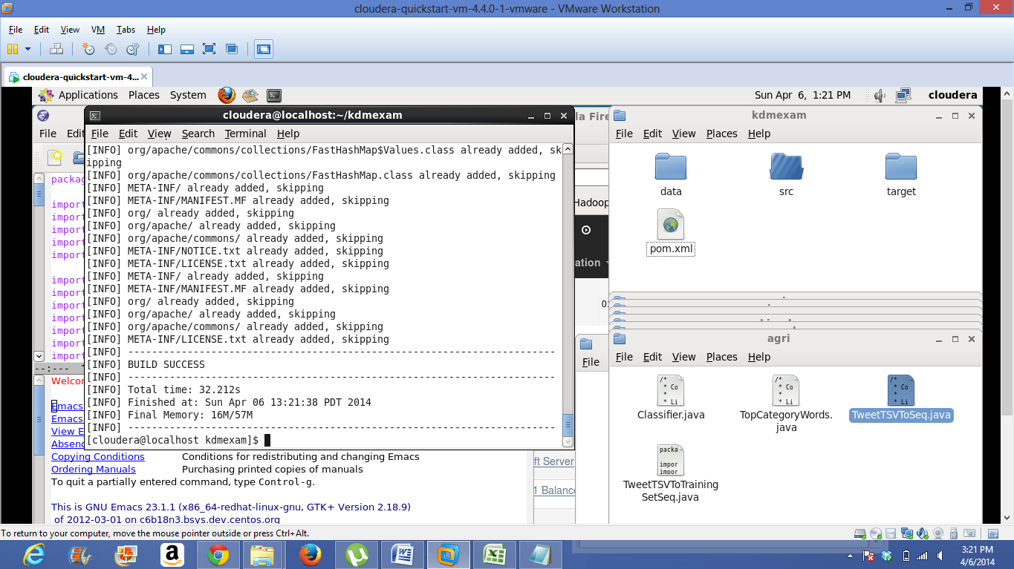

Before training we have to convert training set to hadoop sequence file format.

Then train the data

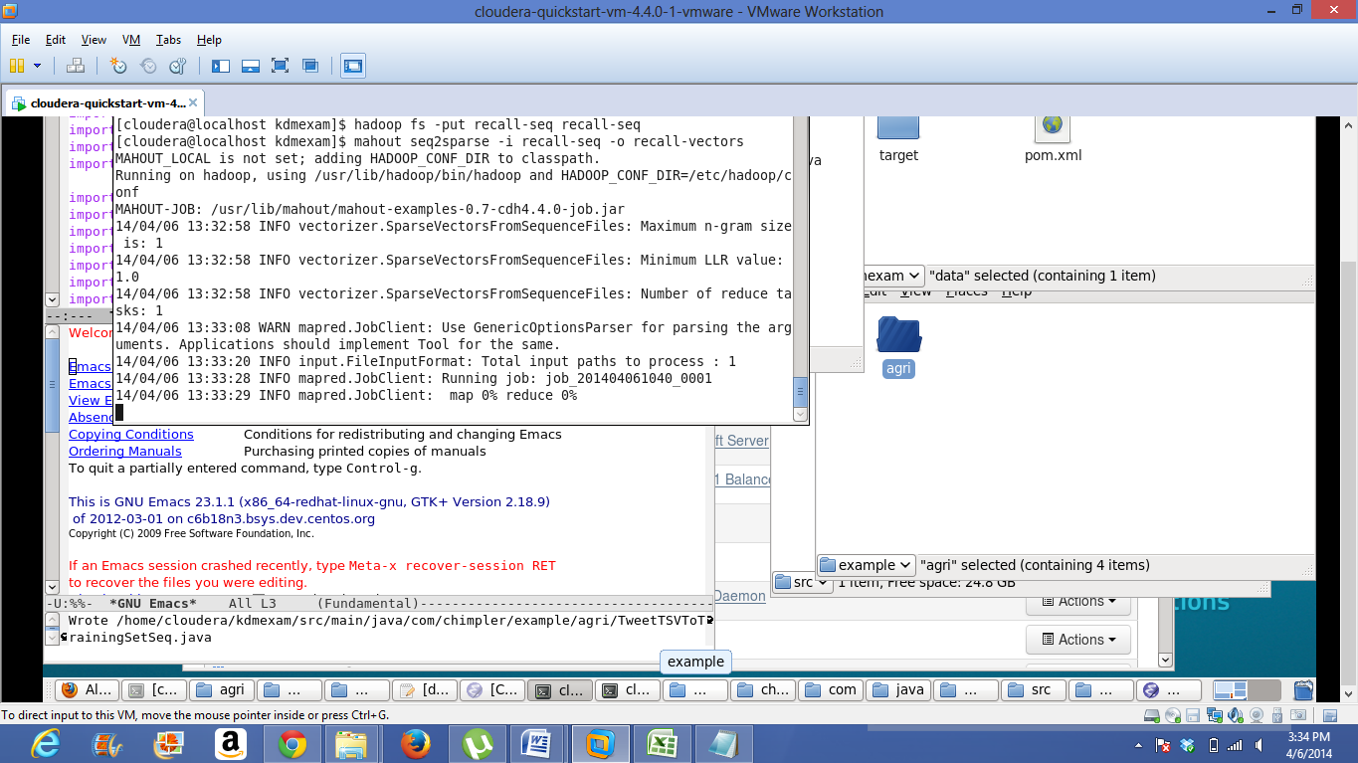

Then it creates the matrix model and label

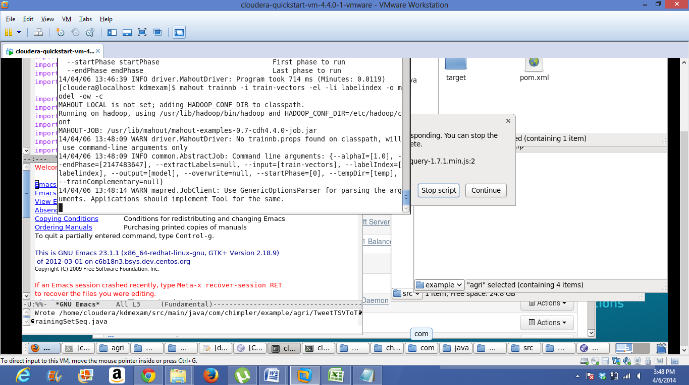

The below figure represents the matrix model which is used to verify whether classifier is working properly or not.

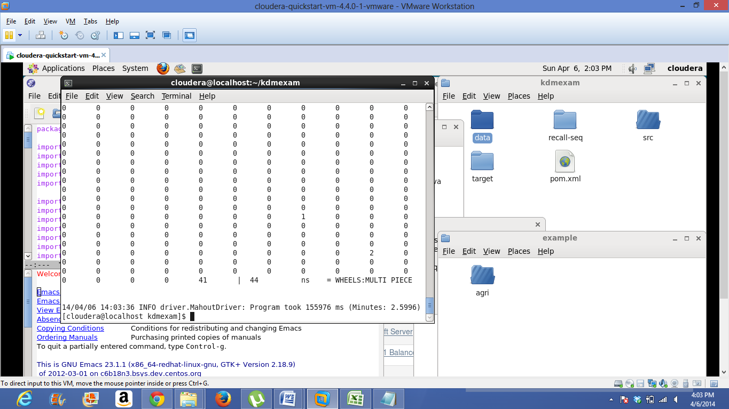

The below figure represents the output. Until this step I used the commands provided in tutorial-7 but I modified in the commands as of my application

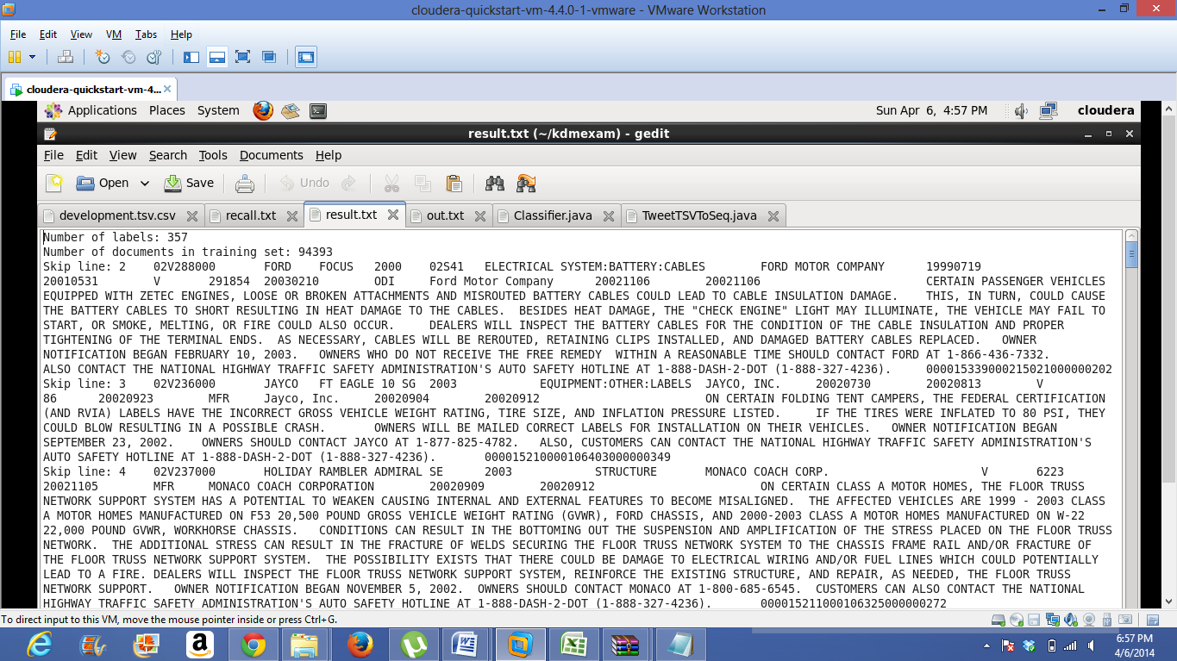

Below screen shot represents output in JSON format.

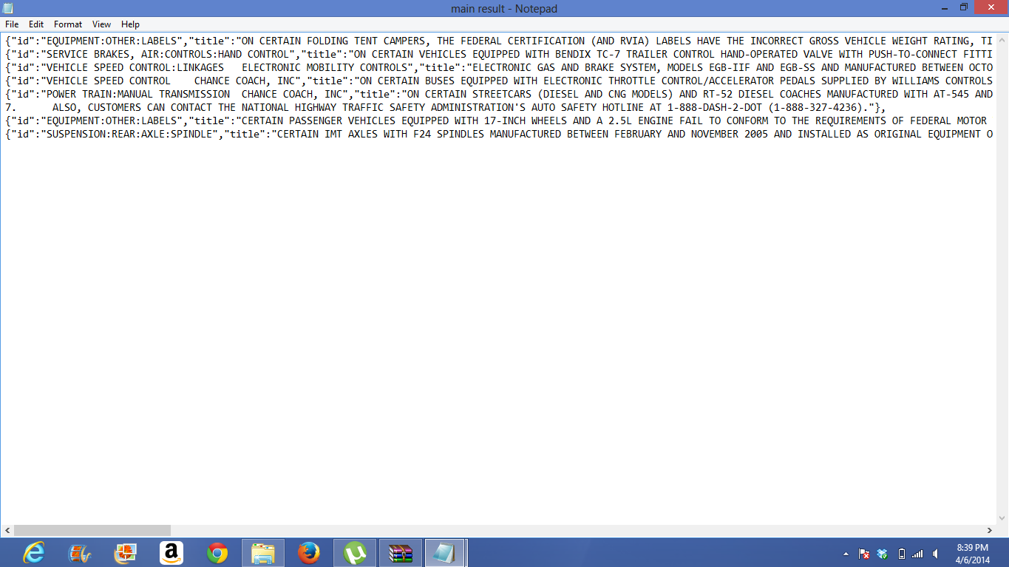

**PUSHING OUTPUT INTO SOLR:**

connecting to UMKC VPN here you have to use umkc sso and password as login id and password.

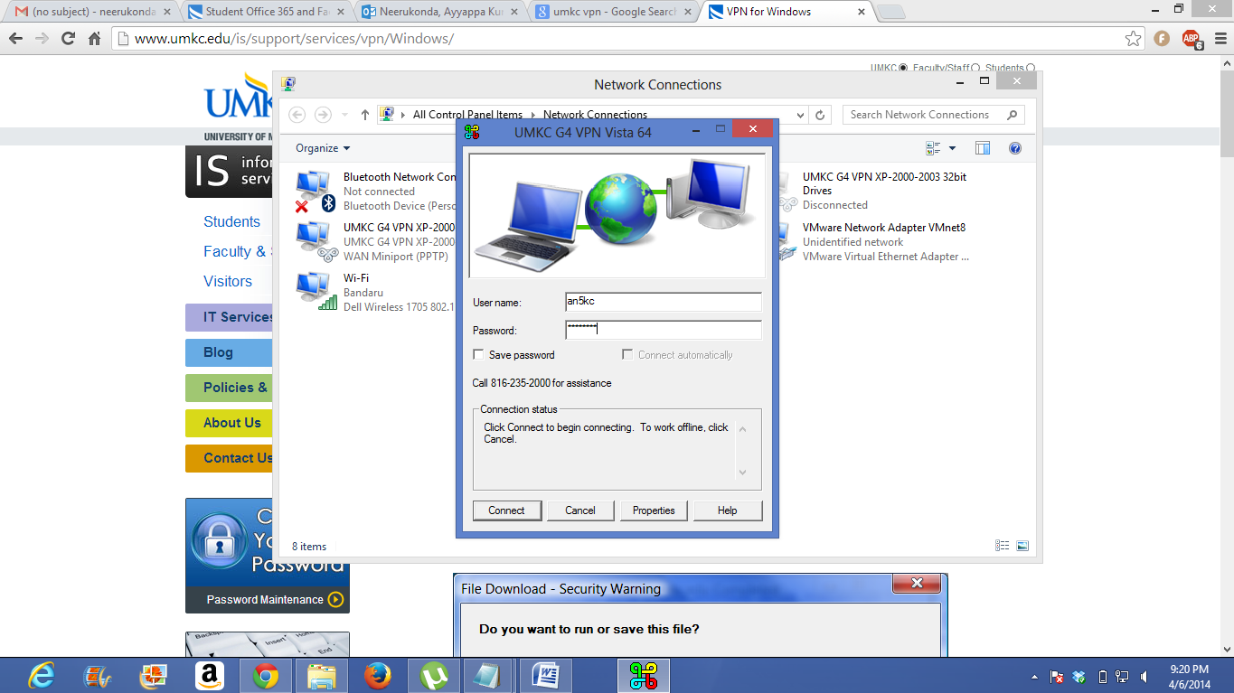

pushing the data into SOLR

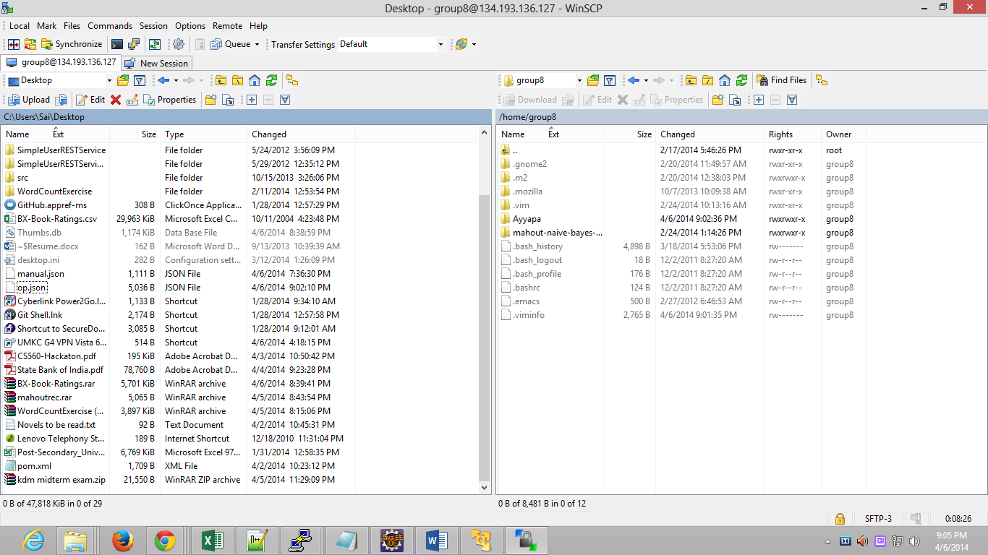

Below screen shot represents that data is successfully sent into the SOLR. Here I pushed the data in to SOLR by using my group login details.

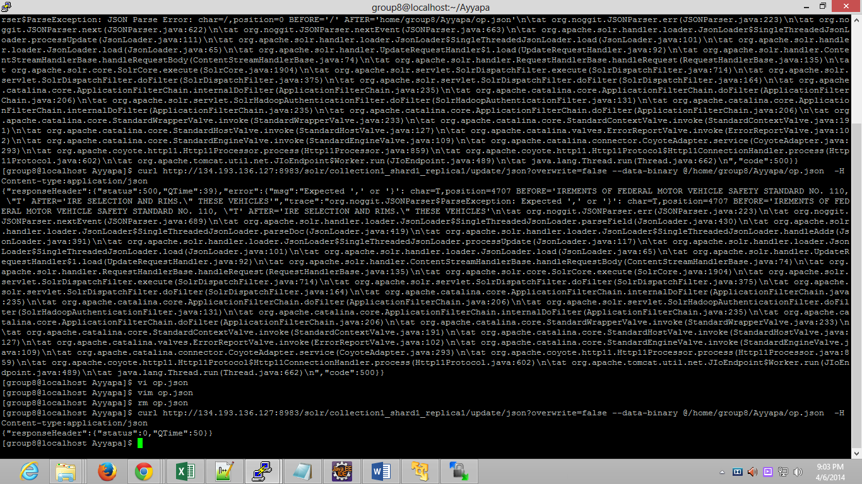

below figure shows retrieval of data from SOLR.

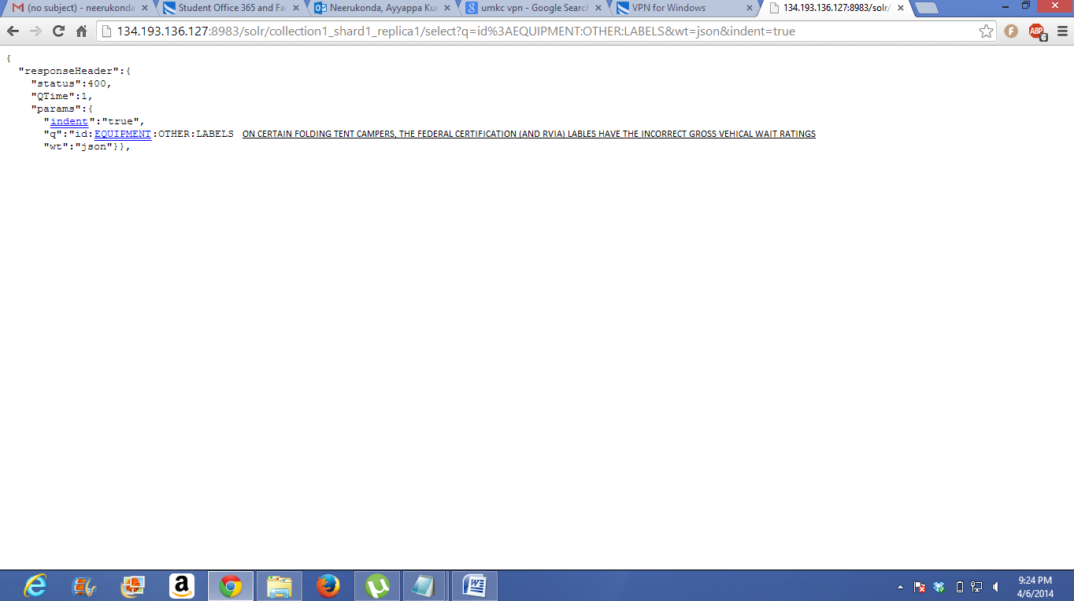

**Mobile application:**

Here I developed the mobile application using JSFIDDLE.

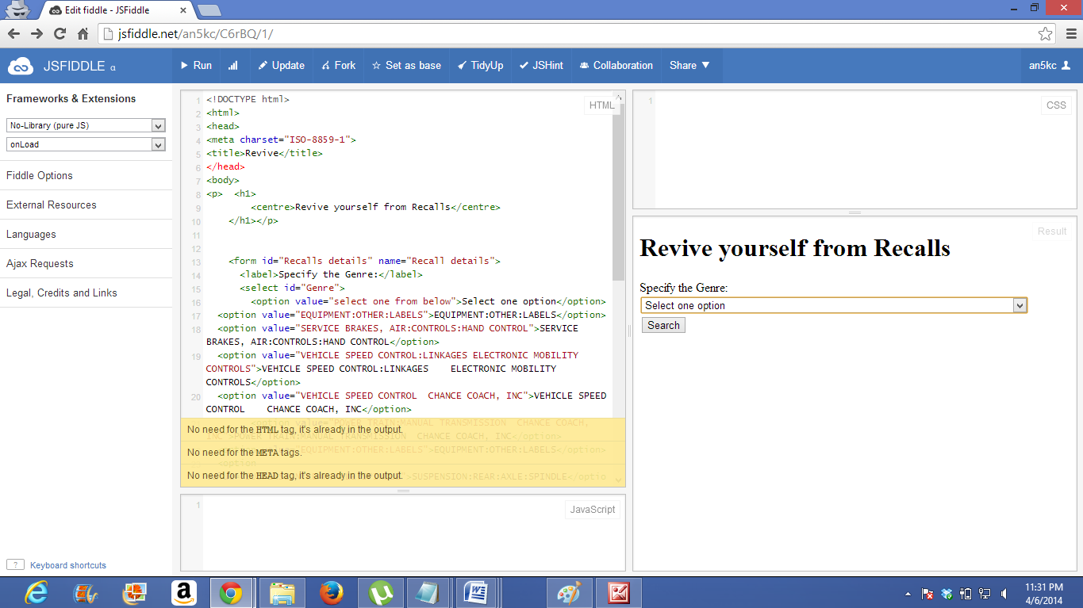

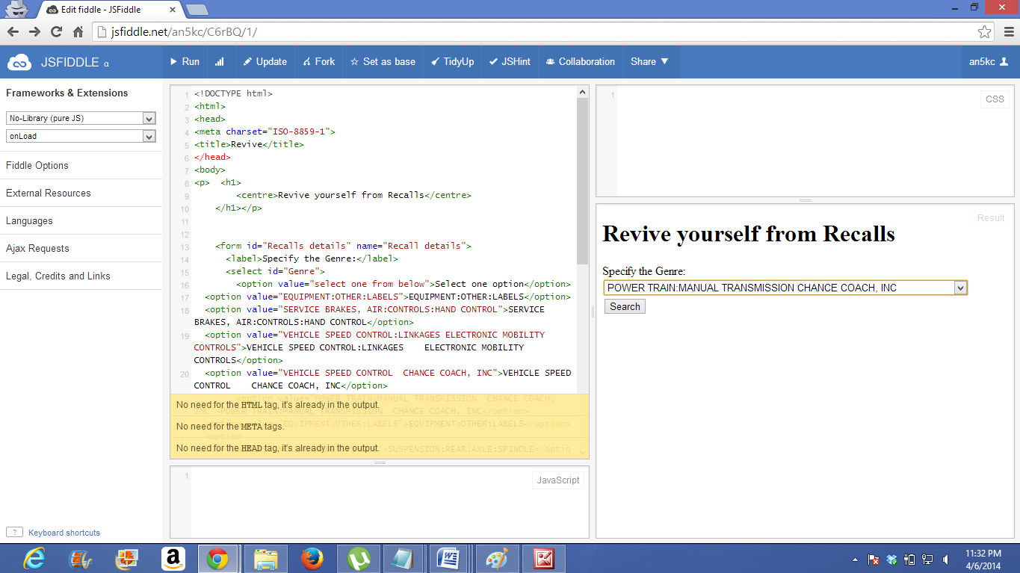

SOLR retrieving link.

<http://134.193.136.127:8983/solr/collection1_shard1_replica1/select?q=id%3AComedy&wt=json&indent=true>

GITHUB LINK:

<https://github.com/kdman5kc/kdm-exam>